**MCA WEEK 9: EXTRACTING MEANING FROM AUDIO**

**TASK 1**: Extract Features

For this task I decided to use three of the original musical pieces – the “Main Themes” from my project.

**TRACK ONE**: HALLOWEEN (1978): MAIN THEME

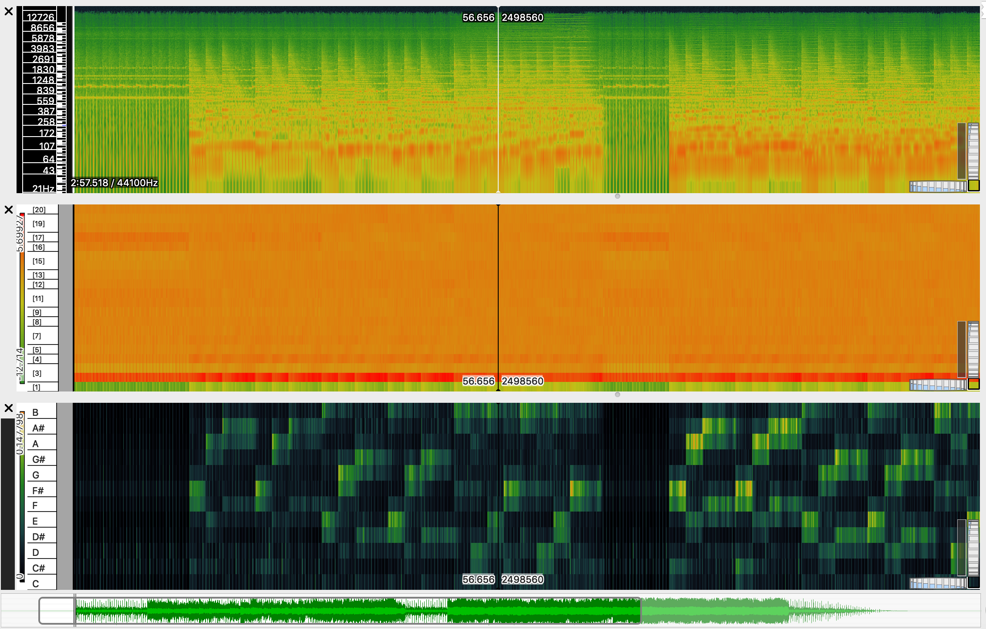

Figure 1. Halloween Visualisation

**TRACK TWO**: ESCAPE FROM NEW YORK (1981): MAIN THEME

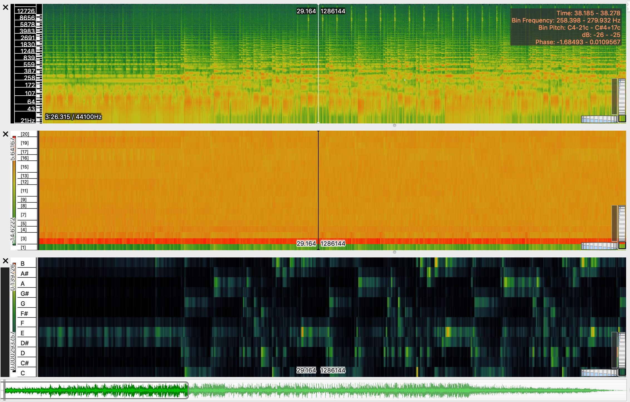

Figure 2. Escape from New York Visualisation

**TRACK THREE**: THE FOG (1980): MAIN THEME

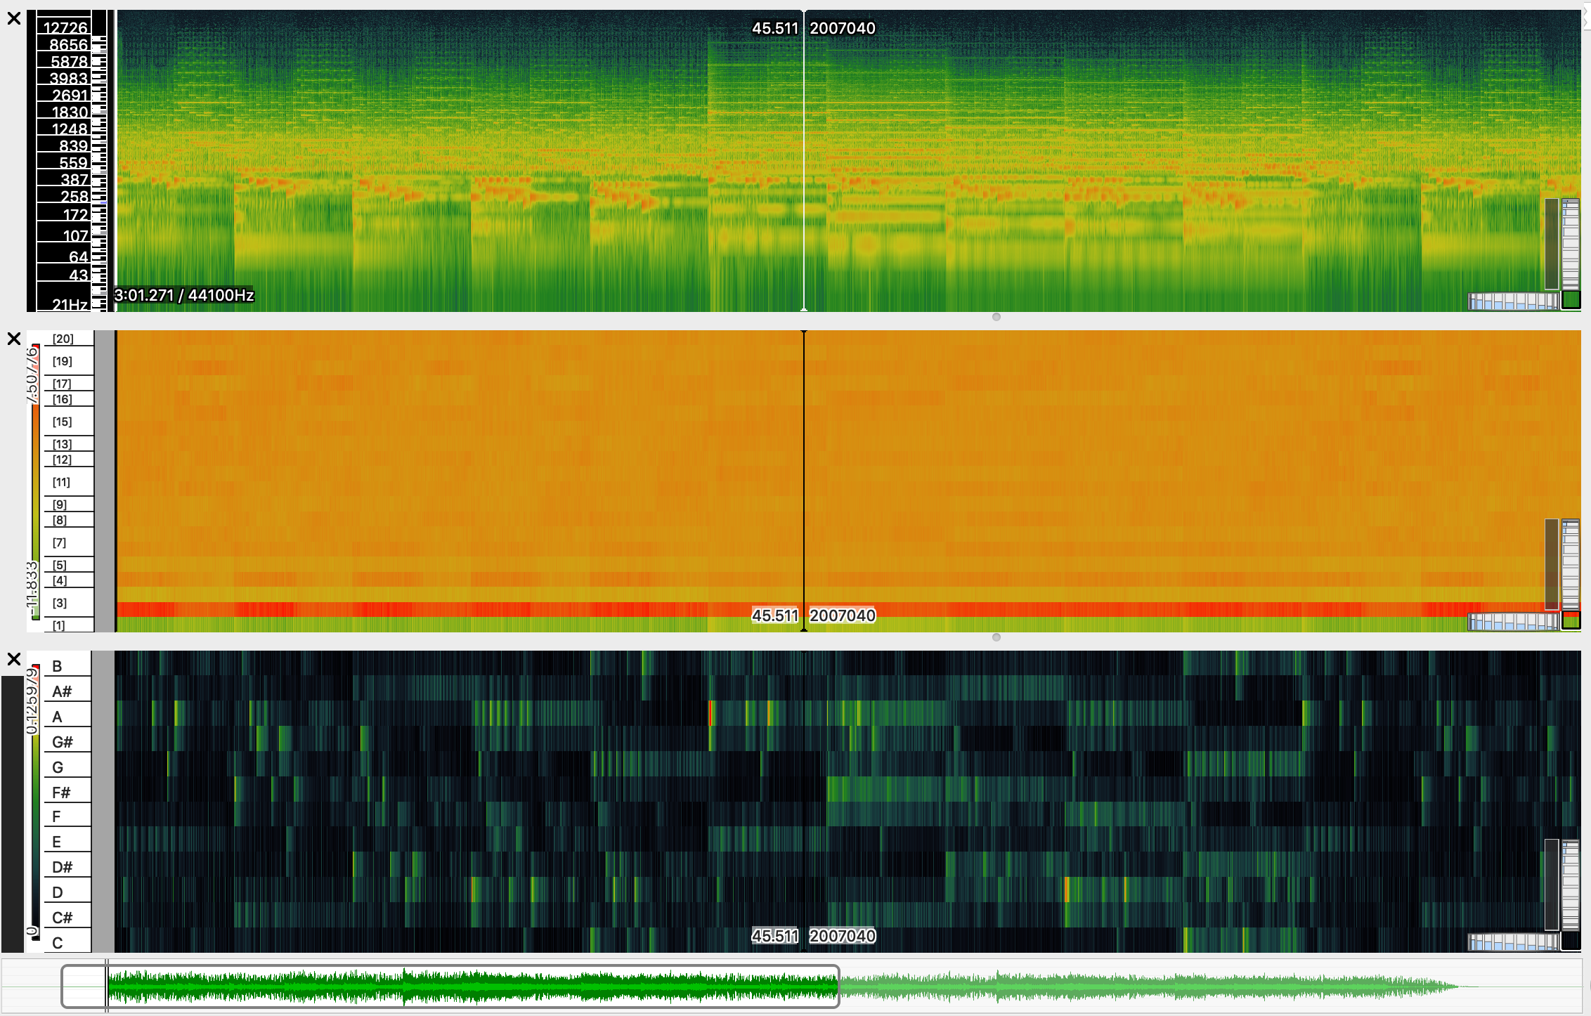

Figure 3. The Fog Visualisation

**MCA WEEK 10: SIMILARITY AND TRANSCRIPTION**

**Task 1: Similarity**

Mean Representation for the tracks.

Taken from the mean Chroma features made using Python, figure 4 is comparison of the 10 tracks in the collection (tracks 7,8, and 9 were replaced by three of my chosen tracks). The 10 plots in the image show the notes charted from the chromatic scale of each track.

Tracks 0, 1, 2, and 3 are from the classical genre.

Tracks 4, 5, and 6 are from the rock genre.

Track 7 is from the jazz genre, 8 is from the pop genre, and 9 is from the ambient pop genre.

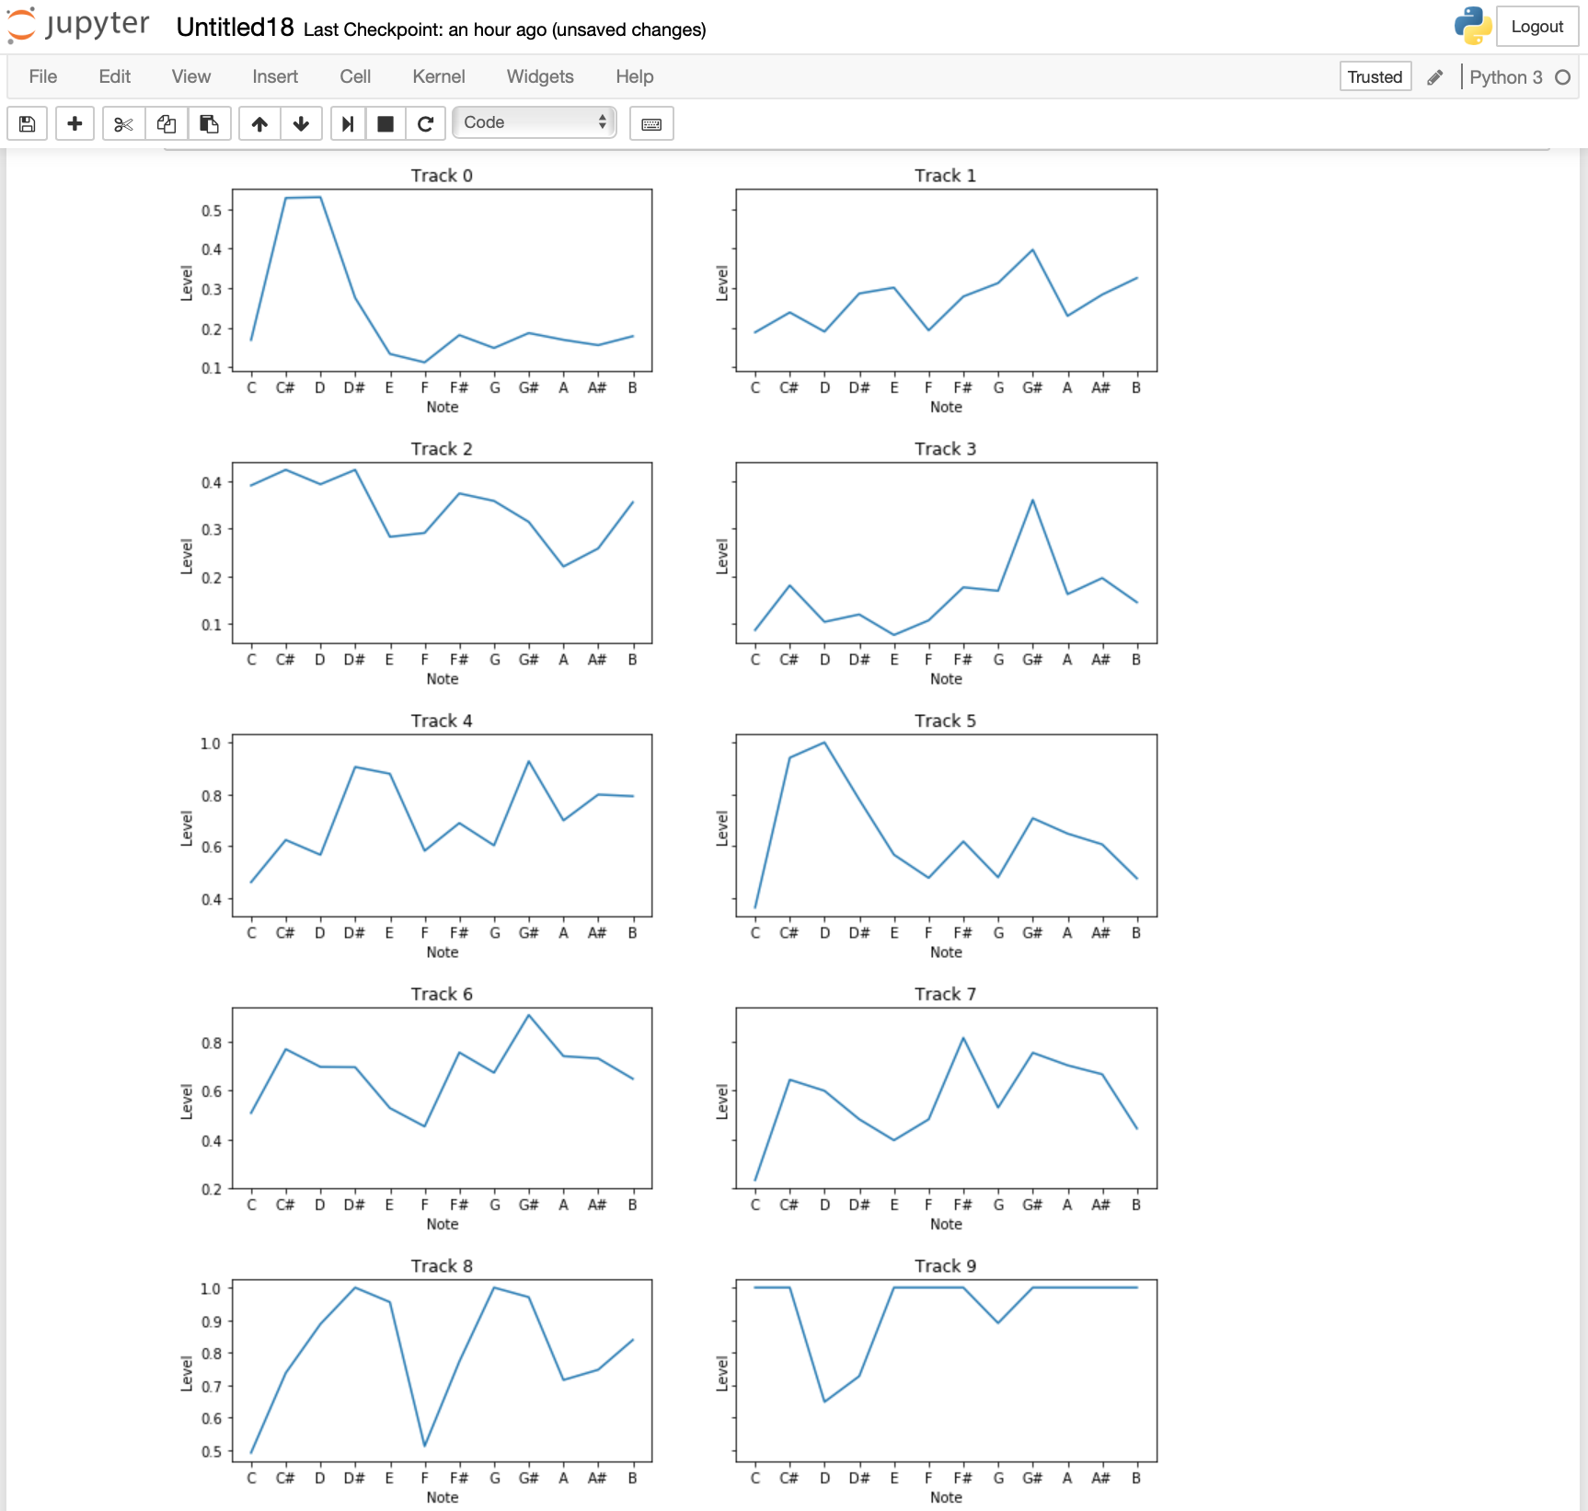

Figure 4. Mean representation chart

Chroma-features matrix.

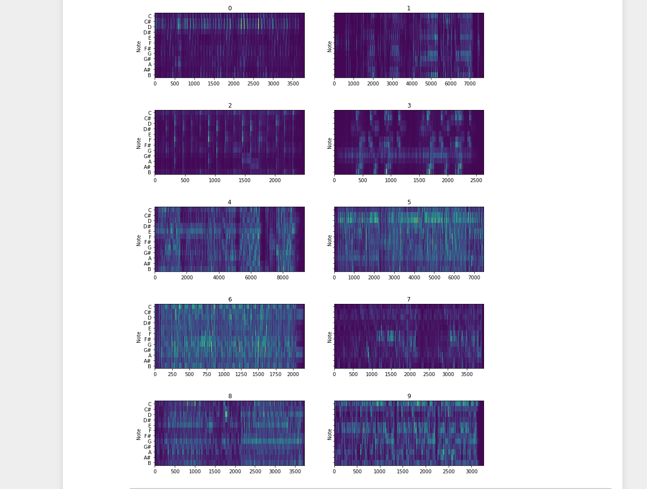

Figure 5. Chromogram comparison

Figure 5 is a comparison of the 10 tracks, which shows 10 Chromograms made using Python. From observing and comparing the 10 plots, it was possible to notice that the different tracks have different lengths, different dynamics, and different amounts of music information. Tracks 4 to 9 (with the exception of track 7) appear quite similar in the amount of notes and information. One could guess they were from similar genres, when in actual fact they are considered to be different genres. Tracks 4, 5 and 6 are from the rock genre and are very similar to one another. Track 8 is from the pop genre, and track 9 is from the ambient-pop genre, and both are very similar to one another. Track 7 is from the jazz genre and appears very similar to tracks 0-3, which are from the classical genre. It is possible that because of the acoustic instrumentation, the spaces between the notes of the music, and the gentler musical dynamics of the jazz track, that it appear more similar to the classical tracks than the rock and pop tracks.

**Task 2: Transcription**

This task was to compare original musical notation from a MuseScore file with a MuseScore file converted into a Wav file, then changed into a midi file via the Sonic Visualizer software, then loaded back into MuseScore as a new musical transcription. The idea is to see what information, if any, is lost following the conversion processes.

Figure 6 shows the original MuseScore transcription with the three different instrumentation parts – The Electric Bass, the Grand Piano, and the Contrabass. It shows that the piece is in 4/4; the BPM is 120; the clef is a bass clef; has 5 bars; the notes are all either quarter notes or crotchets; and there are several rests.

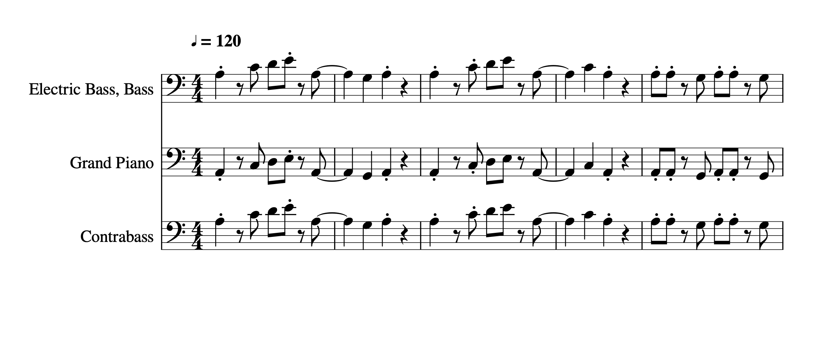

Figure 6. Original MuseScore Transcription

There are several differences in the second transcription (Figure 7). Firstly it is obvious that the instrumentation has changed the transcription to contain one treble clef and one bass clef instead of the 3 bass clefs from the original. The other differences are that some of the notes have changed from the original’s crotchets and quarter notes, into minims, and that augmentation dots have appeared . When playing back the second piece it appears to be playing chords rather than the singular notes of the original.

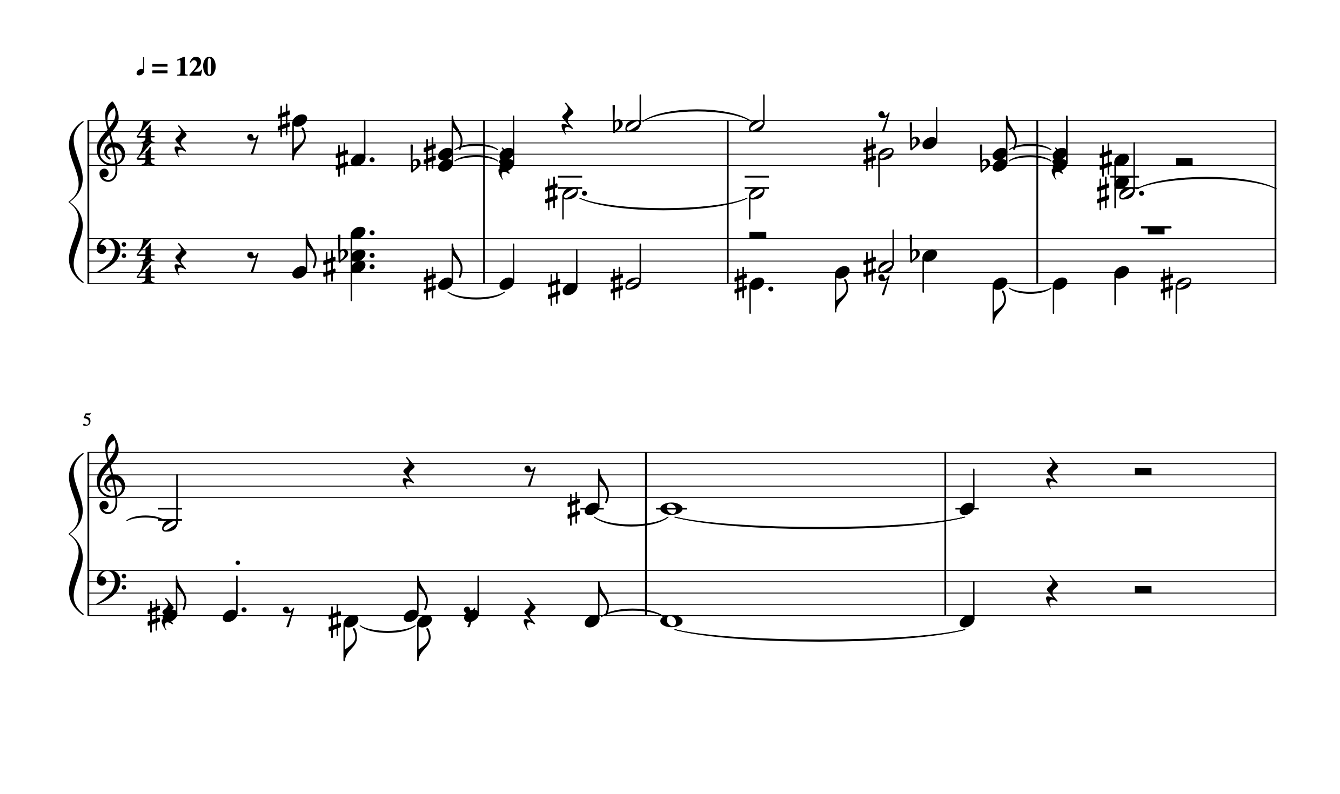

Figure 7. Second transcription